ARTICLES 31 AND 32: ACCESSORY DWELLING UNIT BYLAW FAQ

- What is the new State law regarding Accessory Dwelling Units?
On August 6, 2024, Governor Healey signed the Affordable Homes Act into law (Chapter 150 of the Acts of 2024). You can find information at the following link: https://www.mass.gov/info-details/accessory-dwelling-units
The Act amended the definition of an accessory dwelling unit (ADU) to be 1/2 of the gross floor area of the principal dwelling or 900 square feet, whichever is smaller. The Act allows ADUs by right in any zoning district that allows single-family dwellings.
- When does the State Law go into effect?
The State Law became effective on February 2, 2025. This means that the Town must abide by the new Law and allow an accessory dwelling unit that meets the definition of an ADU by right.
- What are the differences between the current Lincoln Bylaw and the New State Law?
The Planning Board is proposing a bylaw amendment to bring the zoning bylaw into compliance with State Law while retaining the current rules for Accessory Apartments larger than 900 square feet up to 1200 square feet.
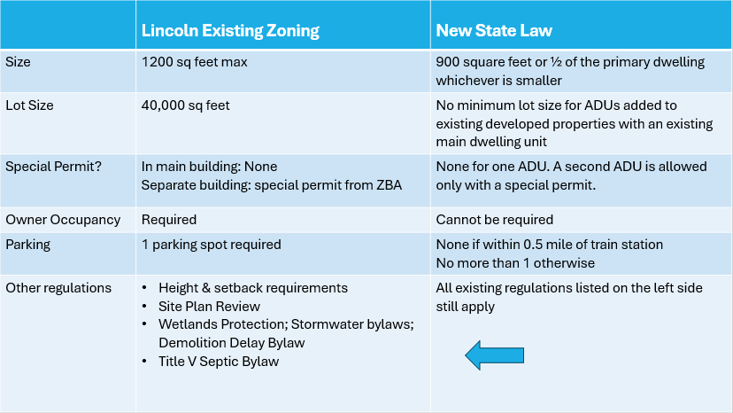
- What does the proposed bylaw do?

The proposed bylaw differentiates Accessory Apartments from ADUs and creates two tiers.
Tier 1: All Accessory Apartments defined as larger than 900 square feet up to 1200 square feet, are subject to existing regulations.
Tier 2: All Accessory Dwelling Units as defined by the State, are permitted by right with some additional safeguards that are allowed by the State Law.
The Bylaw also removes the cap on the allowable number of Accessory Apartments. This is because the State law does not allow a municipality to restrict the number of ADUs, so it makes no sense to cap one and not the other.
- If ADUs are allowed by right, can there be some kind of permitting review?

The proposed bylaw complies with the requirements of State law AND provides safeguards for the Town. State law protects ADUs as a ‘protected use” under the Dover Amendment. An accessory dwelling unit that meets the definition of an ADU, is allowed by right. The proposed bylaw adds protections such as Site Plan Review by the Planning Board for ALL detached ADUs.
State law prevents a municipality from requiring a special permit for an ADU added to a nonconforming lot or structure. The proposed bylaw adds a provision that requires the ZBA to make a Section 6 finding that the ADU is “not more detrimental to the neighborhood” for ADUs on nonconforming lots or added to nonconforming structures. This is NOT a special permit and requires only a majority vote rather than a super majority vote of the ZBA.
- Are there other safeguards baked into the bylaw?

YES:
- existing setback requirements for primary dwellings and accessory structures will apply.
- Site Plan Review by the Planning Board will be triggered if an ADU is added to a primary dwelling and the square footage threshold is met that currently triggers site plan review.
- Wetland Protection regulations apply.
- Historic District process and procedures apply
- Historic Demolition permit processes and procedures apply.
- Title 5 Septic requirements apply

- Will new ADUs affect the Town’s Subsidized Housing Inventory (SHI)?

NO. The SHI is based on the percentage of housing units considered “affordable” up to 80% of Area Median Income. The Assessor’s records do not show accessory units as separate housing units. The current SHI is 12.83% which is well above the required 10%.

- Why are there two separate Town Meeting articles?

- Article 31: Adds the new section 14.4 which is a new change to the zoning bylaw that may produce more housing and requires a majority vote.
- Article 32: Changes existing text for consistency and clarity but is not a new change to produce more housing, requires a 2/3 vote.

